Down on the farm

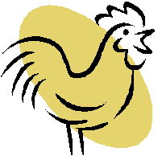

There are some rabbits and chickens in a field.
Together they have 35 heads and 94 feet.
How many rabbits? How many chickens?

1r + 1c = 35
4r + 2c = 94

